Name: Saja Kosanović
E-mail: saja.kosanovic@pr.ac.rs
Institution: University of Priština in Kosovska Mitrovica, Faculty of Technical Sciences
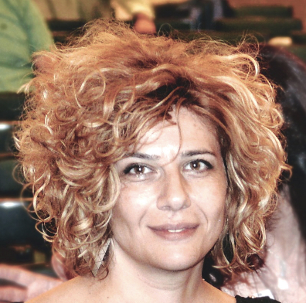 | Saja Kosanović is Associate Professor at the Department of Architecture – Faculty of Technical Sciences in Kosovska Mitrovica, where she teaches architectural design and sustainability of built environment and seeks to link students’ design work with real-world environmental challenges and socio-cultural demands of growing complexity. She holds graduate diploma in Architecture, and MSc and PhD in Architecture & Urbanism received from the Faculty of Architecture of University of Belgrade. Her current research interests are sustainability and resilience assessments, development of strategies for sustainable, resilient and healthy built environment, and higher education. She is pioneer in development of national model for environmental assessment of buildings adjustable to local conditions and building type/status; author of numerous research publications; member of editorial/scientific boards of several international journals/conferences; and reviewer in international scientific journals. She is coordinator for international projects at the FTS and coordinator or participant in several EU projects/programmes.
References (max. 5 relevant references)
Fikfak, A., Kosanović, S., Konjar, M. & Anguillari, E. (eds) (2018) Sustainability and resilience: socio-spatial perspective. TU Delft Open. ISBN: 9789463660303
Kosanović, S., Klein, T., Konstantinou, T., Radivojević, A. & Hildebrand, L. (Eds.) (2018) Sustainable and resilient building design: approaches, methods and tools. ISBN: 9789463660327
Kosanović, S., Novaković, N. & Fikfak, A. (Eds.) (2018) Pregledi održivosti i otpornosti građene sredine. TU Delft Open. ISBN: 978-94-6366-088-4
Fikfak, A., Kosanović, S., Konjar, M., Grom, J. & Zbašnik-Senegačnik, M. (2017) The impact of morphological features on summer temperature variations on the example of two residential neighborhoods in Ljubljana, Slovenia. Sustainability 9(1):122, DOI: 10.3390/su9010122
5. Kosanović, S., Hildebrand, L., Stević, & G. Fikfak, A. (2015) Resilience of inland urban areas to disasters occurred due to extreme precipitations. Open Urban Studies and Demography Journal, 2015, 1, (Suppl 1-M5), 41-51. DOI: 10.2174/2352631901401010041
This project has been funded with support from the European Commission. This publication reflects the views only of the author, and the Commission cannot be held responsible for any use which may be made of the information contained therein.

